Final Year Report

Project Title: **Pre-Color Visualizer for Smart Phone**

**Supervisor: Dr. Aarij Mahmood Hussaan**

**Group Members: Farhan-ul-Haq Khan – 14815**

**Naveed – 14921**

**Introduction:**

**Scope:**

* App can be used by Home owners, Color shops, under construction buildings etc…
* Paint industry for showing the customers the effects of their paint on the houses in real-time.

**Objectives and Goals:**

* To allow homeowners to pre-visualize the effects of applying different colors on their walls, doors, ceilings, etc.
* To achieve the aforementioned goal using a mobile application objectives.
* To be able to identify different objects automatically using static images.
* To be able to change colors of the identified objects.
* To change colors keeping into account the light variations.

**Features:**

* Detection of different objects (walls, doors, ceilings, etc.) in an automatic manner.
* Ability to choose colors from a variety of different option and apply them to the detected objects.
* Ability to apply colors according to the light intensity for more realistic visualization.

**Overview of the Model:**

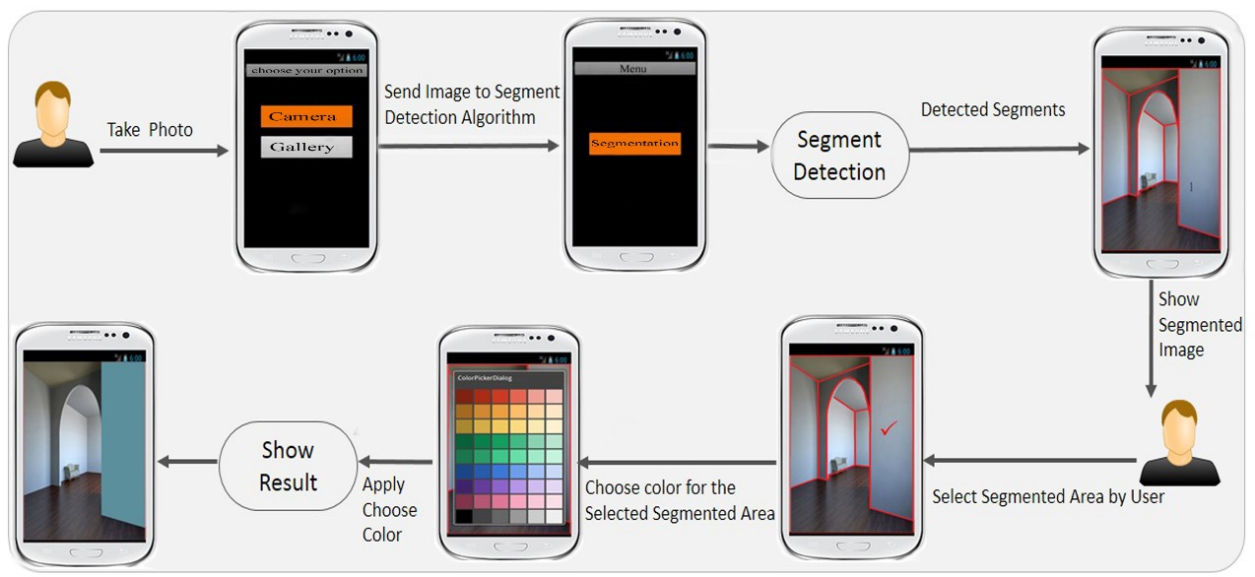

**Explanation of the Model:**

1. User will either take a photo from his/her smartphone or select an image from the phone’s gallery.
2. The image is then sent to our detection engine
3. The detection engine will detect the different objects from the image
4. The detected segments will be shown to the user
5. The user will select a segment and a color from the provided color pallet
6. Finally, our app will apply the chosen color of the selected segment taking into consideration the light variations.
7. And the user will have the same image but with the colors s/he wanted.

**Technology Used:**

* Eclipse (Kepler 4.3)
* Java SDK (SDK version 8)
* Android SDK (SDK version 22.0.4)
* OpenCV 2.4.6
* OpenCV for Android (OpenCV version 2.4.6)

**Conclusion:**

**Source:**

1. <http://forum.xda-developers.com/showthread.php?t=1722325.com%252Fshowthread.php%253Ft%253D1722325%3B514%3B800>
2. <http://www.clker.com/clipart-14899.html>